NAAN MUDHALVAN

NAME:Renuga S

COURSE:SALESFORCE

NM ID:

26BC61A70639190A0F94F4C326C9F20E

Task1:

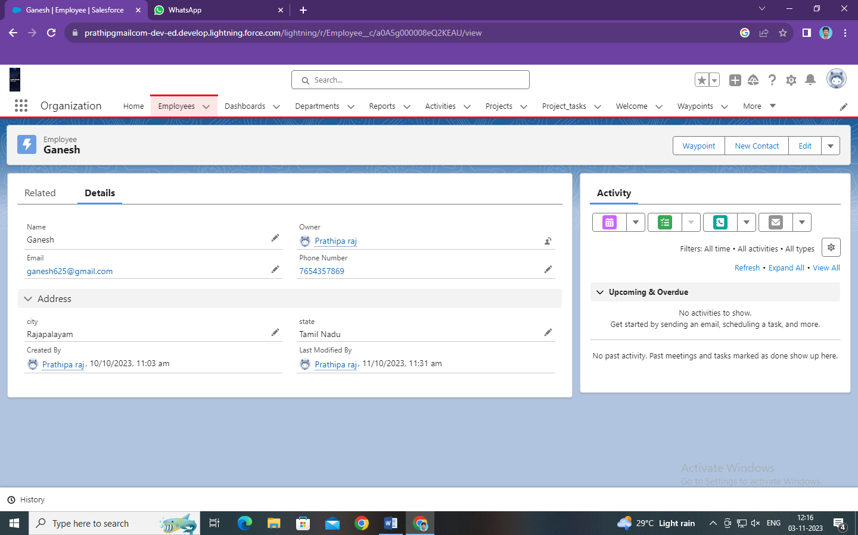

Task 2:

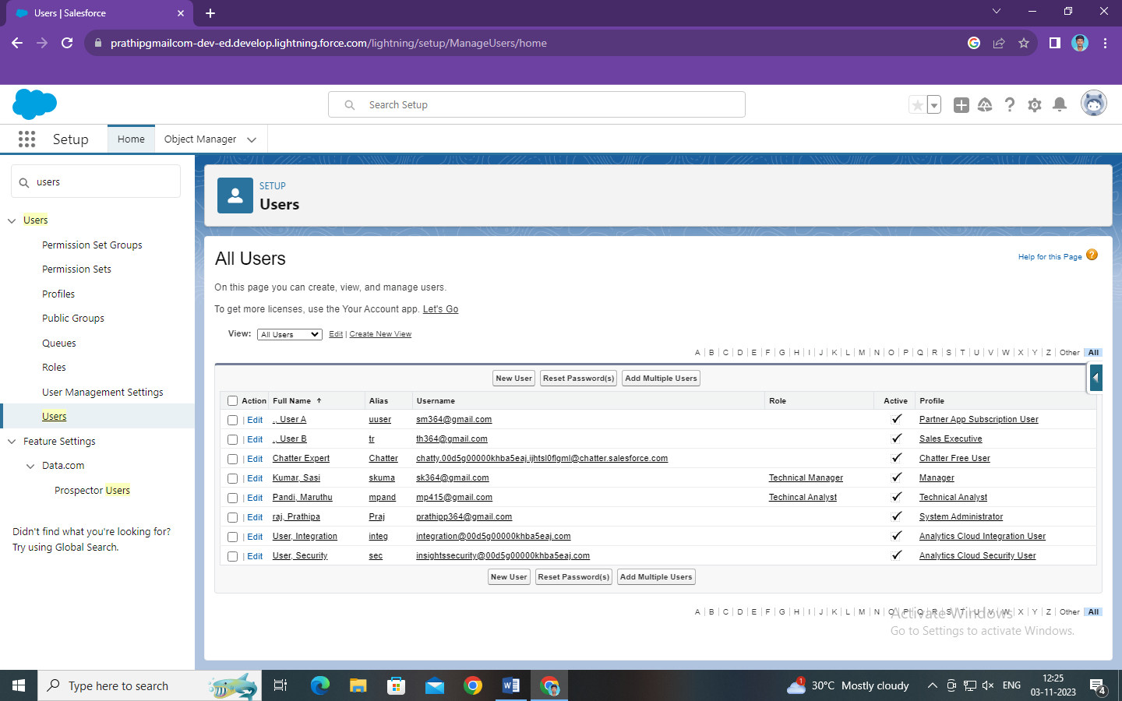

Task 3:

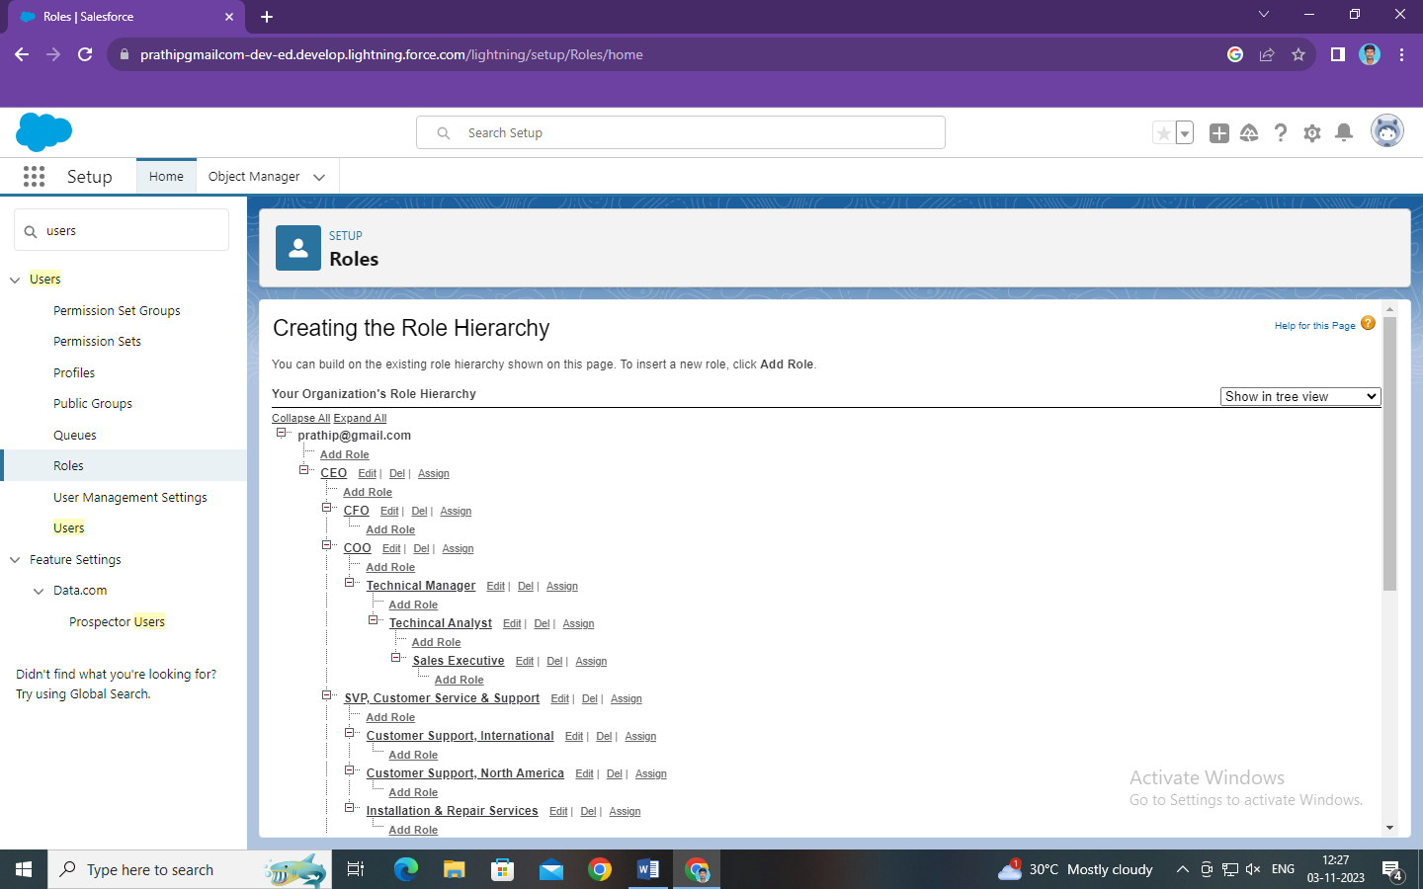

Task 4:

